## **Scott Mottola & Michael Roseweir**

## **iPhone User Flow**

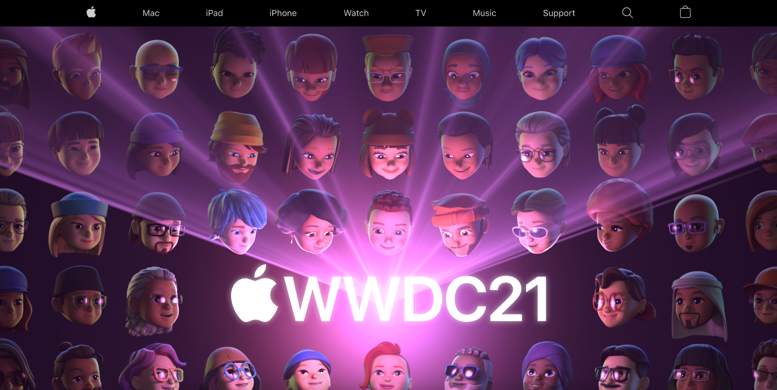

* From the home page, the way you can get to the iPhone feature page would be to click on the iPhone button at the top of the screen.

V

* Once on there are several paths you can take to purchasing an iPhone.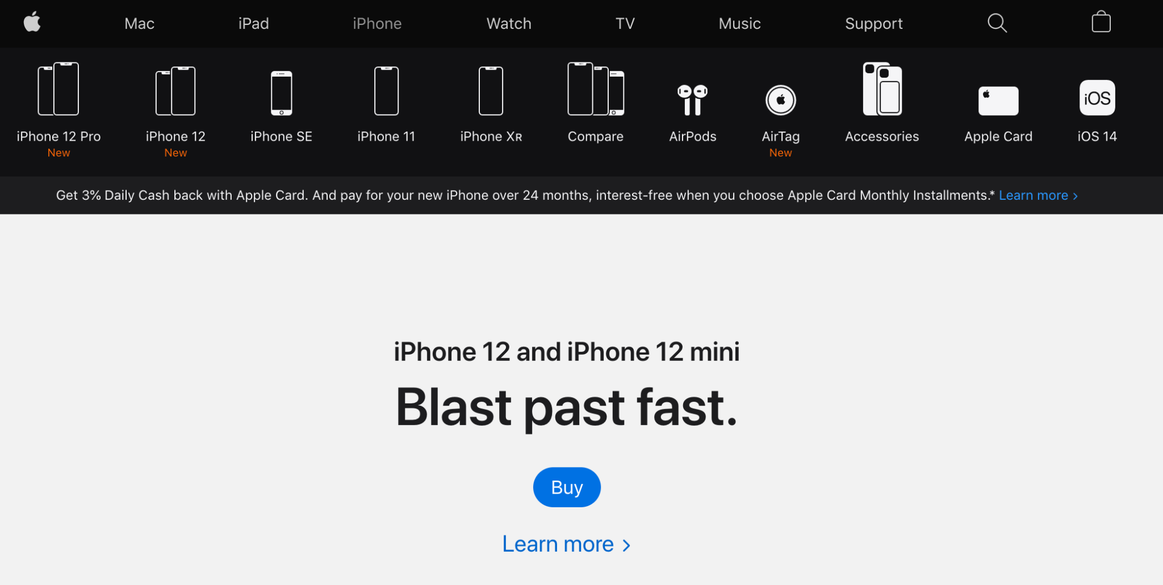

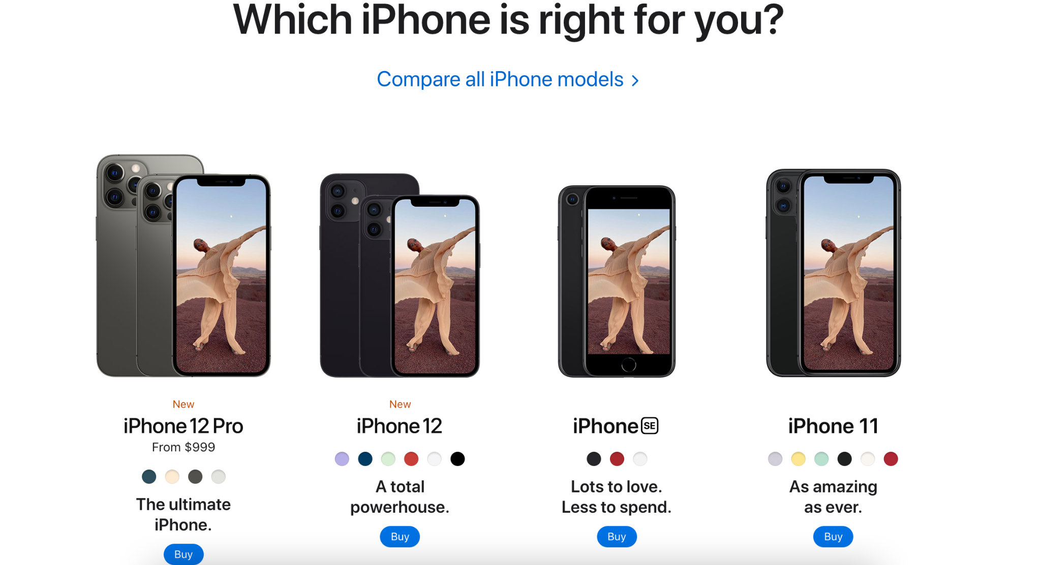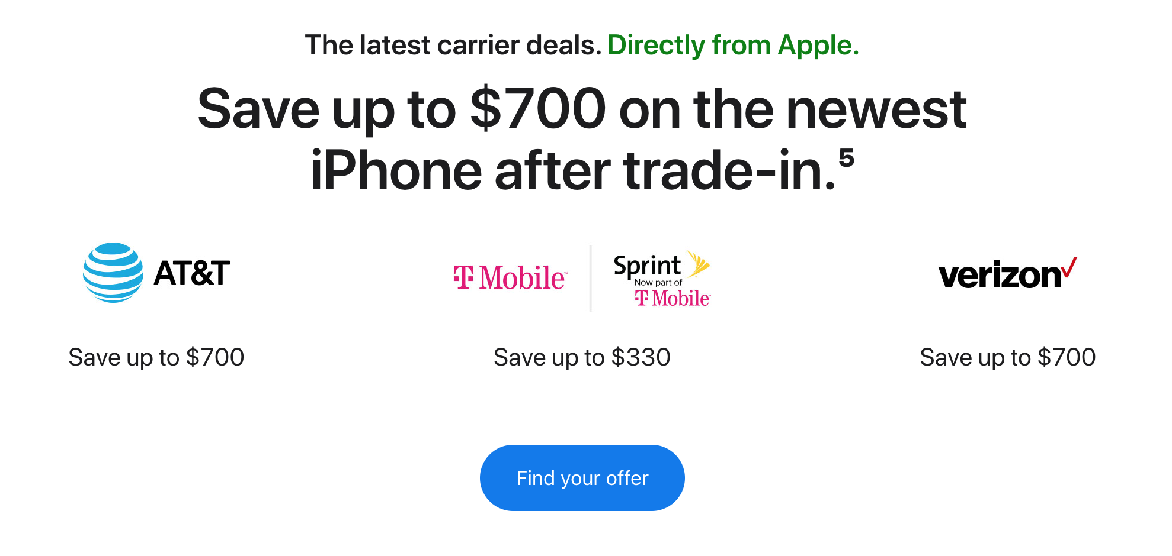

* On Apple’s iPhone feature page it is littered with blue buy buttons on each full screen, which all take you directly to the purchase page.

V

* Once you are on the purchase page you are able to select which model you would like, the color of the device, the carrier of your choice, the storage capacity of your device, and the option to trade in.

V

* Once you have selected the iPhone of your choice the next screen the website takes you to with the continue button is the checkout screen where you are able to add payment and shipping information.

**User Flow Reflection**

* The process for purchasing an iPhone is relatively simple, however the multitudes of ways to get to the same screen can cause option paralysis.
* Once you are on the iPhone purchase screen, you are able to easily select the sub-model, color, carrier, storage capacity, and the option to trade in your existing device and continue on to the purchase screen.
* The iPhone customization screen follows a waterfall methodology, forcing consumers to select one item at a time before they are able to continue through the selections.
* The way in which Apple’s website is designed very closely matches the simplicity of Apple’s user experience.

## 

## 

## 

## 

## 

## **User Stories + Descriptions**

* As a returning educated consumer, I want the fastest way to check out an iPhone using the least amount of screens.
  + One of the first things that you see on the iPhones web page is a blue “Buy” button in the middle of the screen. Taking the consumer directly to the checkout page of Apple’s most consumer friendly iPhone.
* As an active individual, I want to see the fitness tracking capabilities of an iPhone when paired with my smart watch.
  + Further down on the iPhone’s page there is a page that allows people to view the Fitness+ feature of the iPhone and Apple Watch. Showing the connectivity options between an iPhone and an Apple Watch, as well as new Virtual Fitness classes and trainers.
* As a financially focused person, I want to purchase an iPhone as cheaply as possible.
  + The fourth section has three options of different providers and the deals you can have with each one when buying an iPhone. The next page tells each deal in more details and the differences but after that page it goes to the same iPhone purchase page as the others.
* As a technologically knowledgeable individual, I want to purchase the most suitably capable iPhone.
  + The third section of the iPhone page has a list of recent iPhones that have a small comparable table of popular specs for each phone.
* As a technologically deficient person new to Apple products, I want to see how I can get the most out of my iPhone and its features.
  + Directly under the “Get more out of your iPhone” header there is a link that allows individuals to sign up for a virtual session to get started with their iPhone. The sessions cover basics like how to navigate your phone and adjust settings on the device.

**Trello share link:** [**https://trello.com/invite/b/jBRsvsmD/838eb2ee654eb58a22450aed0f0df46d/iphone-product-page**](https://trello.com/invite/b/jBRsvsmD/838eb2ee654eb58a22450aed0f0df46d/iphone-product-page)